Normalized Interplay Matrices

# Figure S1

Brain, 10 months, Histone H3.2

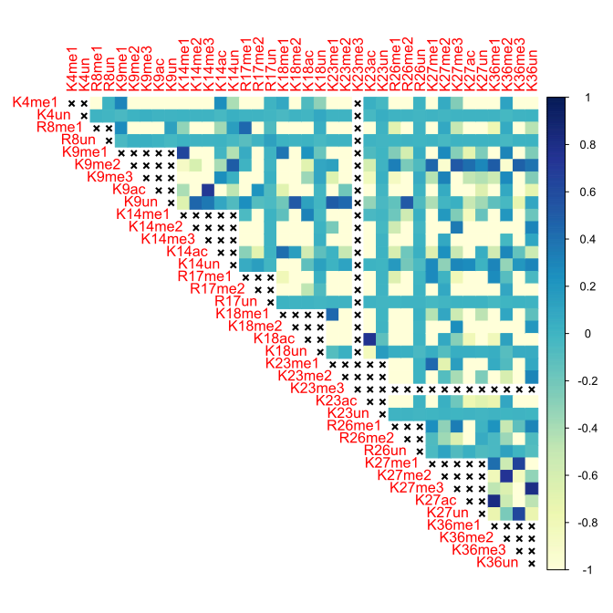

# Figure S2

Brain, 10 months, Histone H3.3

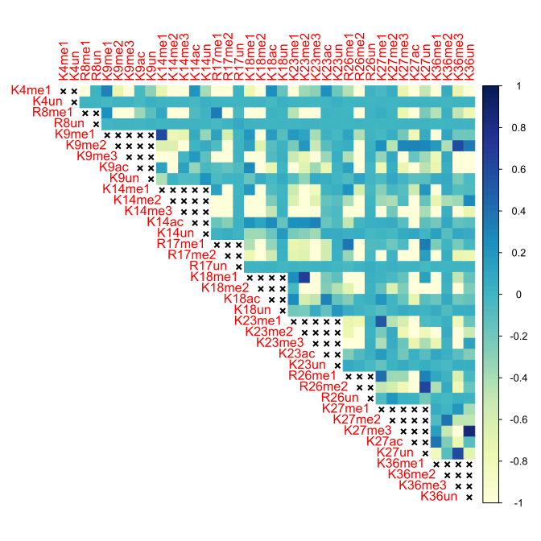

# Figure S3

Brain, 18 months, Histone H3.2

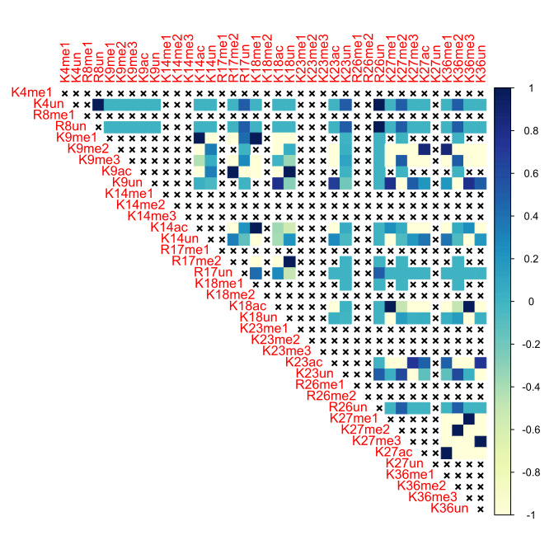

# Figure S4

Brain, 18 months, Histone H3.3

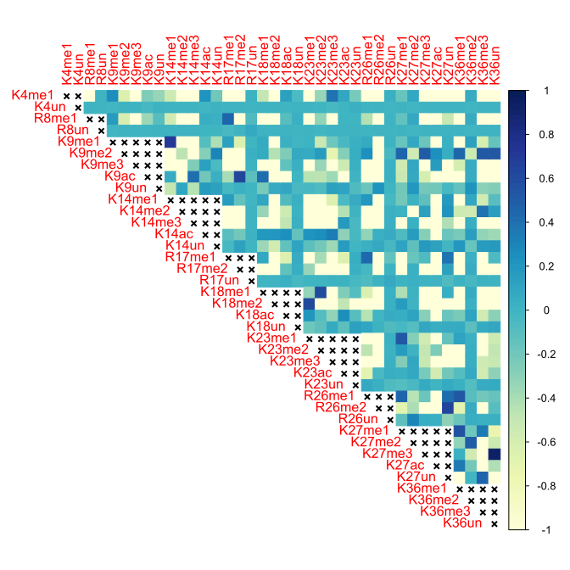

# Figure S5

Brain, 24 months, Histone H3.2

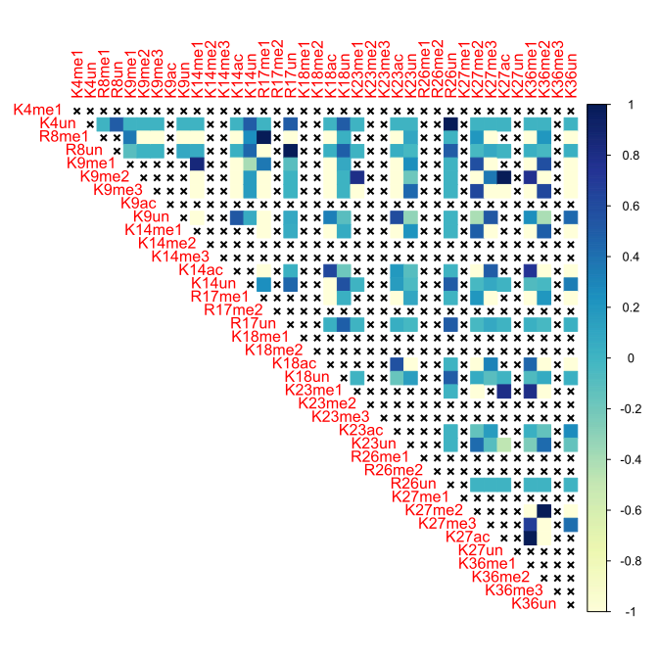

# Figure S6

Brain, 24 months, Histone H3.3

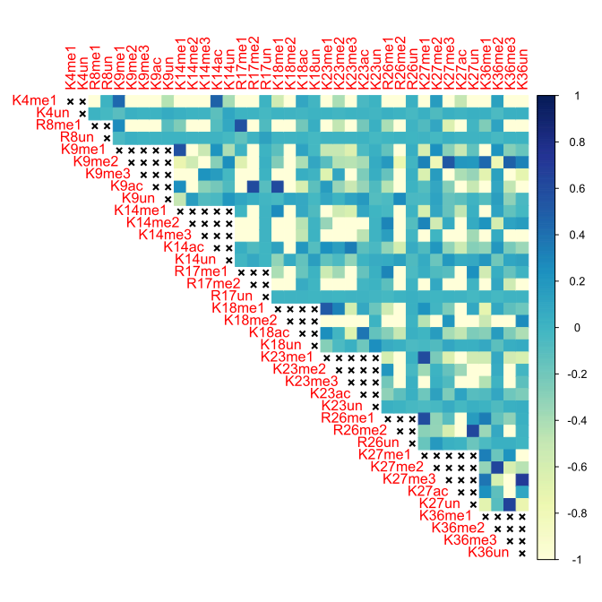

# Figure S7

Brain, 3 months, Histone H3.2

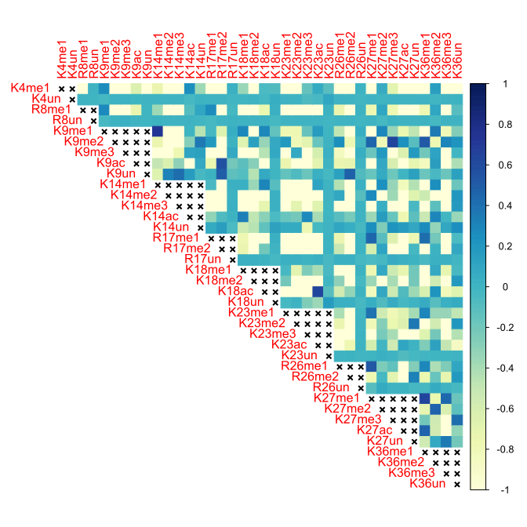

# Figure S8

Brain, 3 months, Histone H3.3

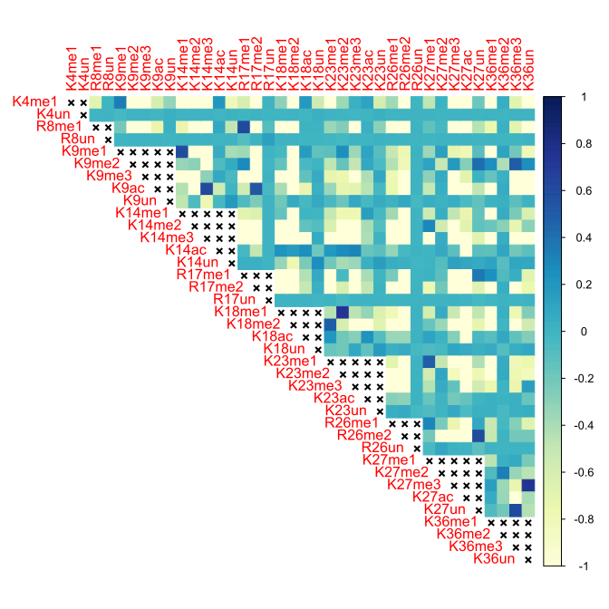

# Figure S9

Brain, 5 months, Histone H3.2

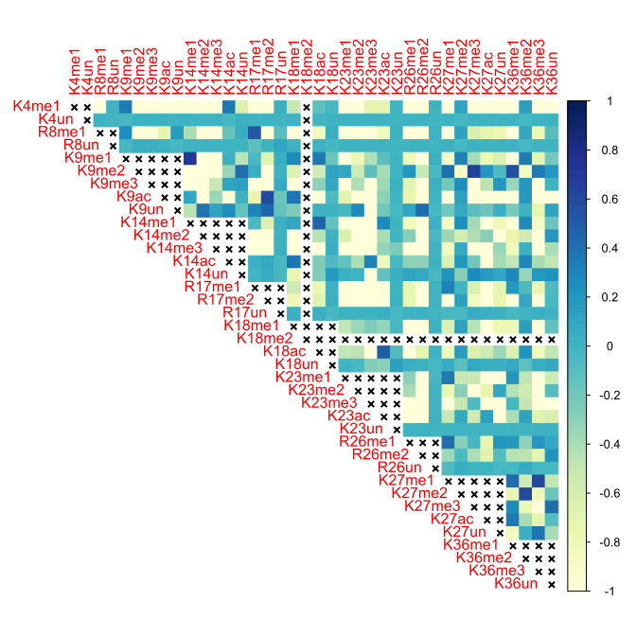

# Figure S10

Brain, 5 months, Histone H3.3

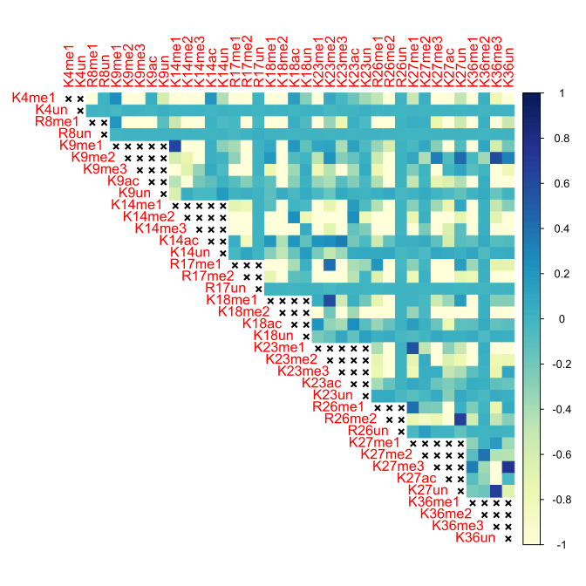

# Figure S11

Heart, 10 months, Histone H3.2

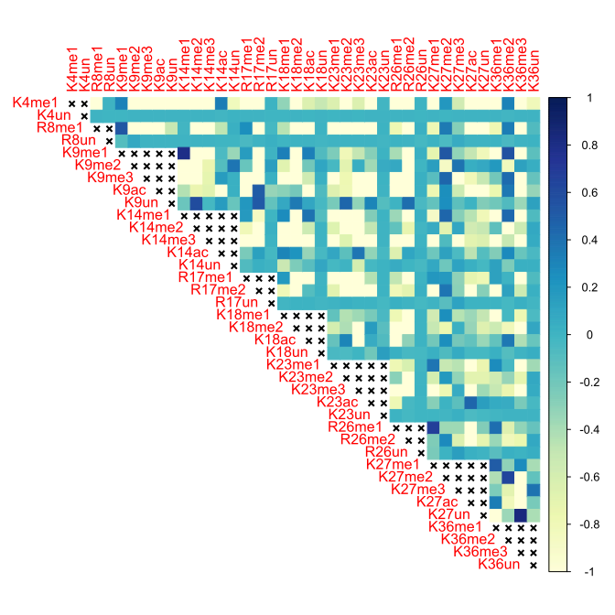

# Figure S12

Heart, 10 months, Histone H3.3

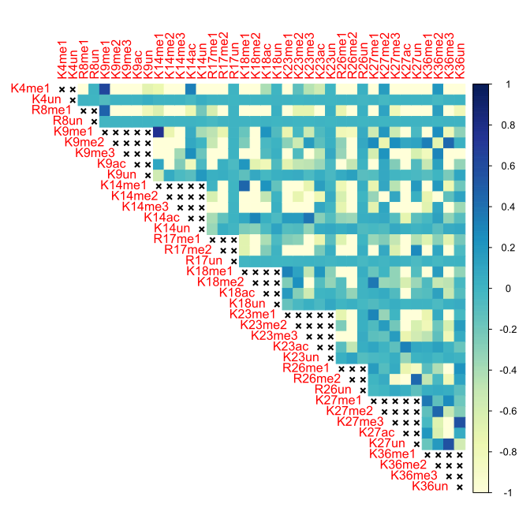

# Figure S13

Heart, 18 months, Histone H3.3

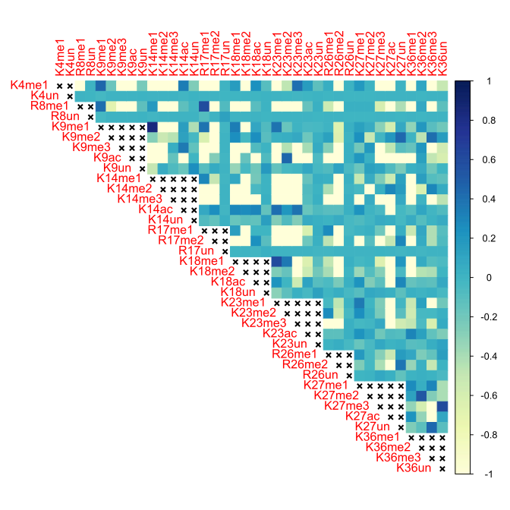

# Figure S14

Heart, 24 months, Histone H3.2

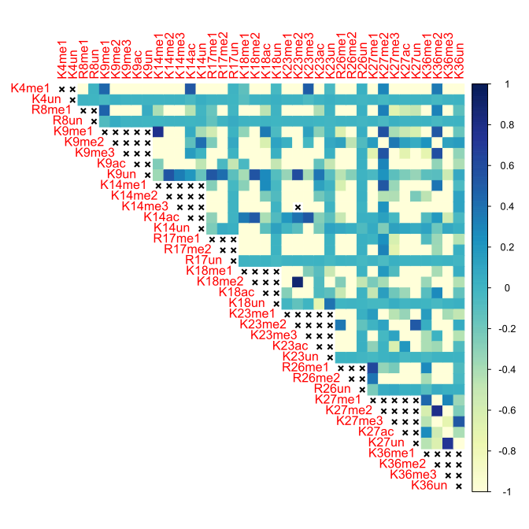

# Figure S15

Heart, 24 months, Histone H3.3

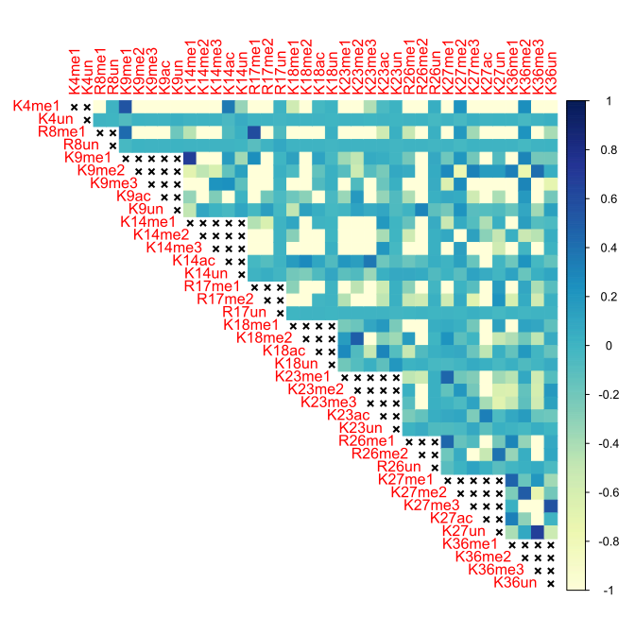

# Figure S16

Heart, 3 months, Histone H3.2

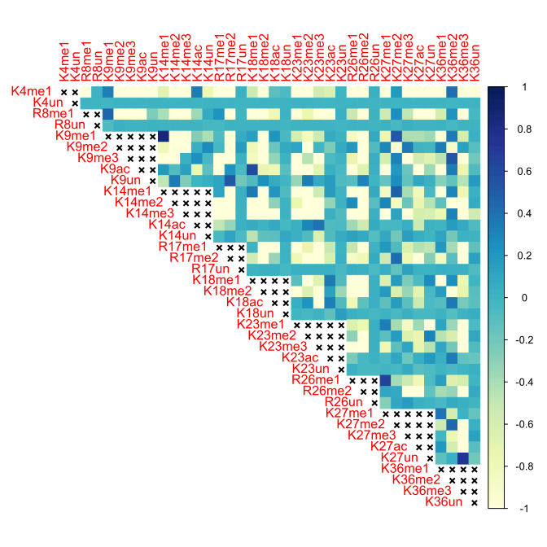

# Figure S17

Heart, 3 months, Histone H3.3

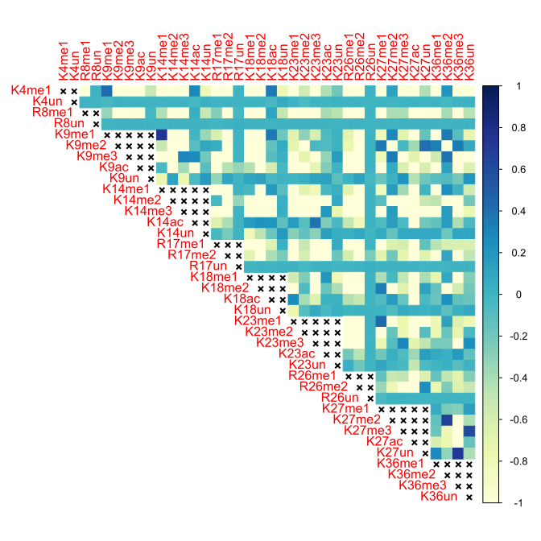

# Figure S18

Heart, 5 months, Histone H3.2

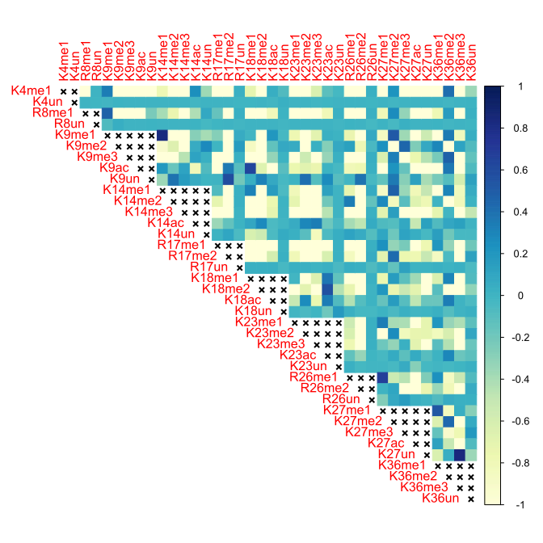

# Figure S19

Heart, 5 months, Histone H3.3

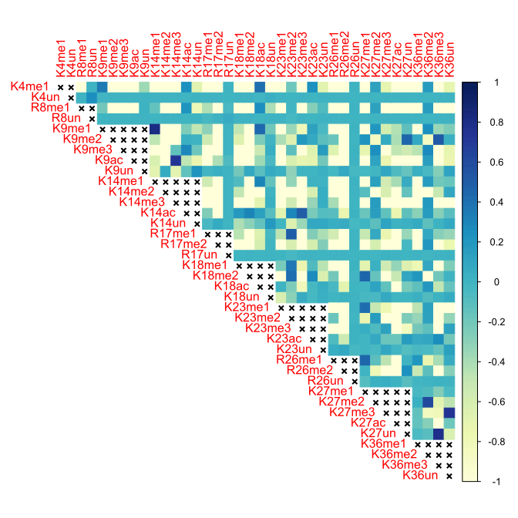

# Figure S20

Kidney, 10 months, Histone H3.2

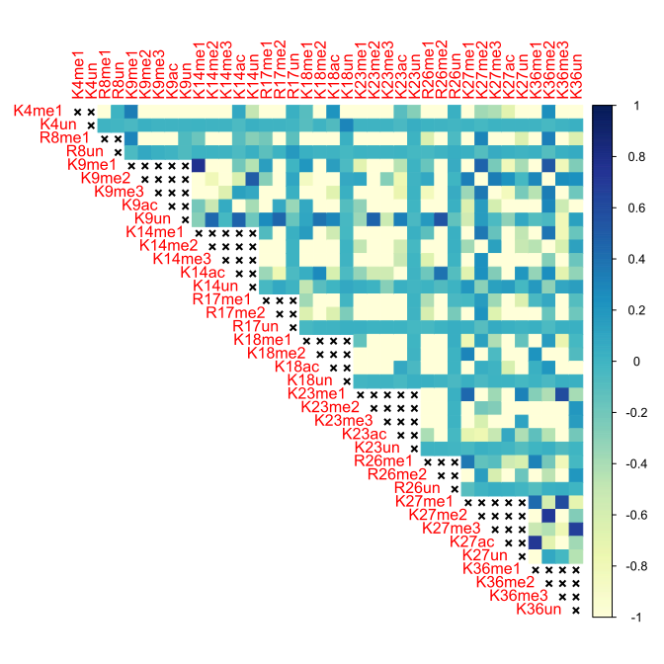

# Figure S21

Kidney, 10 months, Histone H3.3

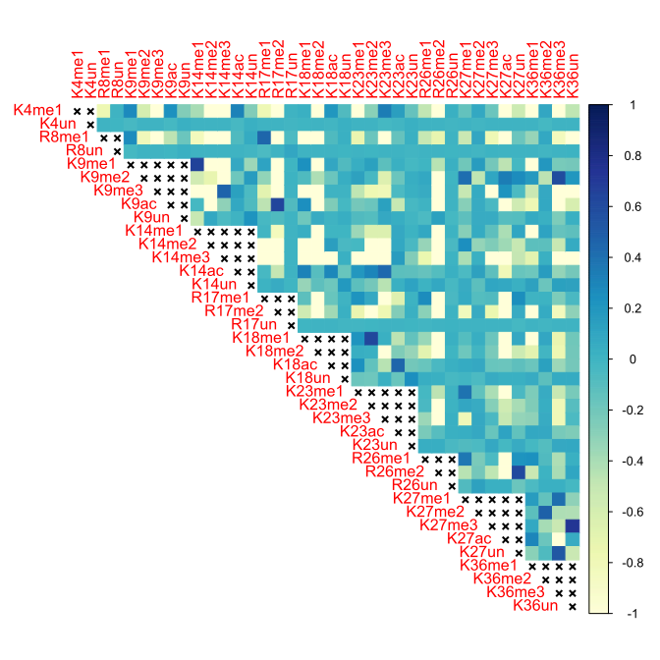

# Figure S22

Kidney, 18 months, Histone H3.2

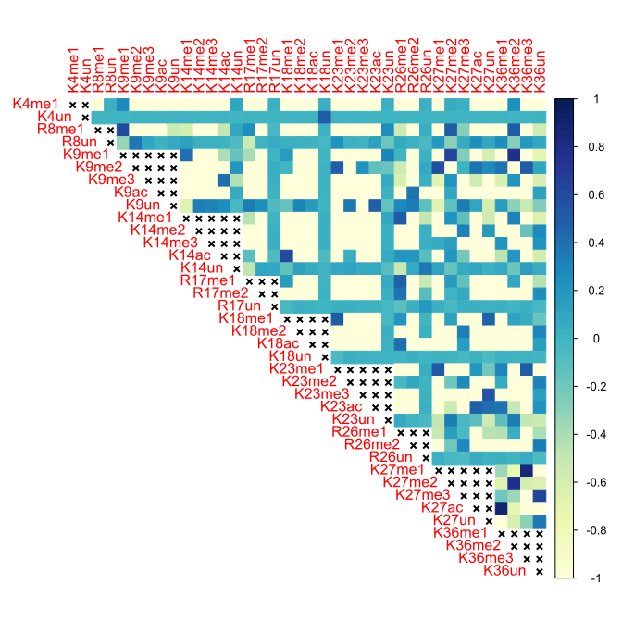

# Figure S23

Kidney, 18 months, Histone H3.3

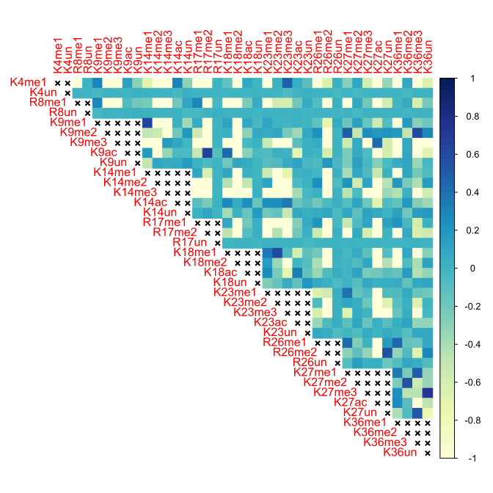

# Figure S24

Kidney, 24 months, Histone H3.2

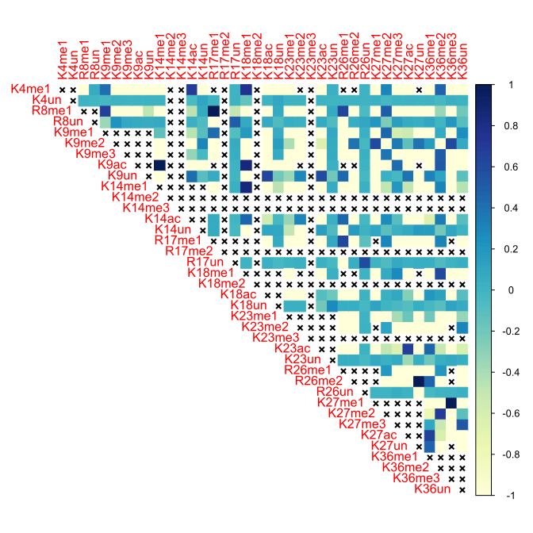

# Figure S25

Kidney, 24 months, Histone H3.3

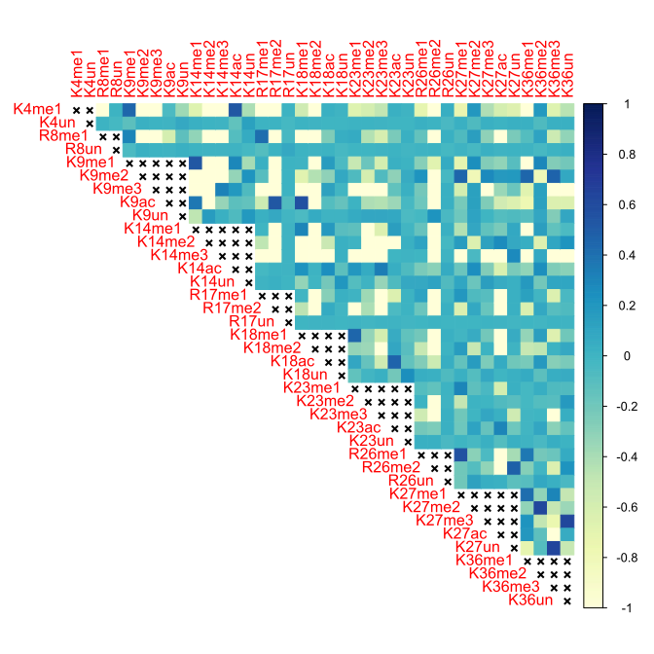

# Figure S26

Kidney, 3 months, Histone H3.2

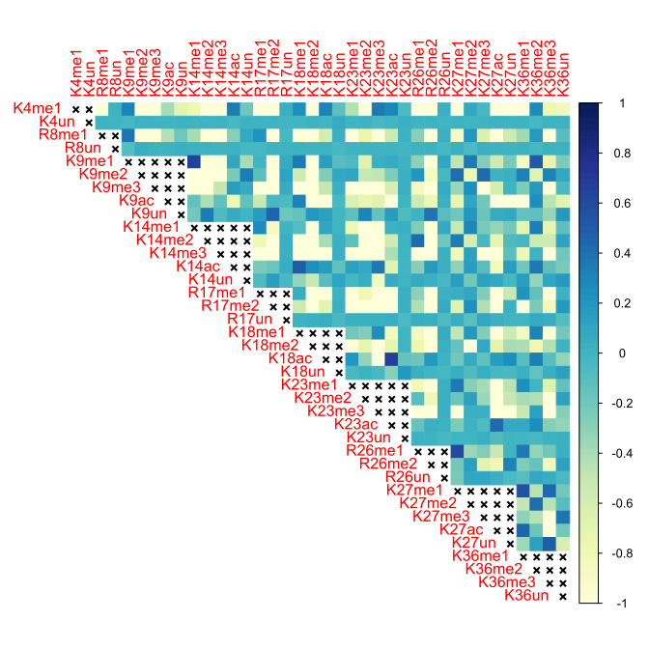

# Figure S27

Kidney, 3 months, Histone H3.3

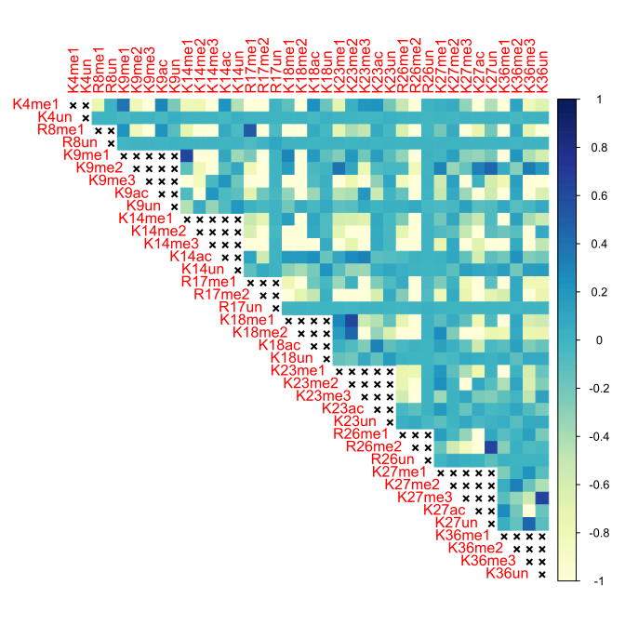

# Figure S28

Kidney, 5 months, Histone H3.2

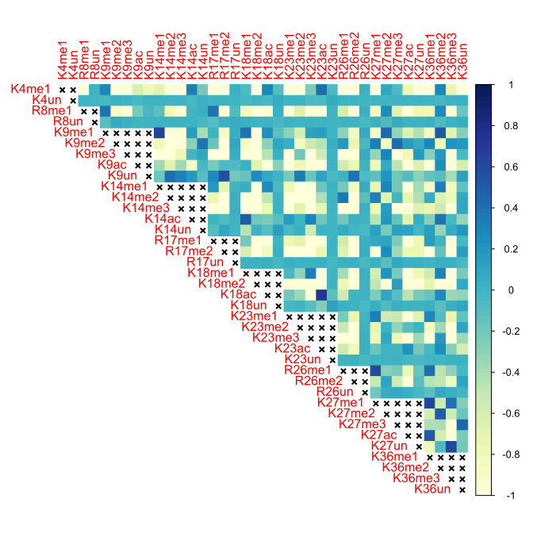

# Figure S29

Kidney, 5 months, Histone H3.3

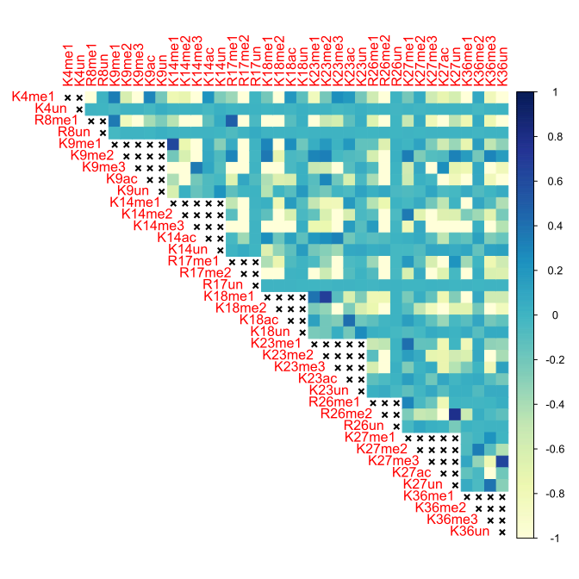

# Figure S30

Liver, 10 months, Histone H3.2

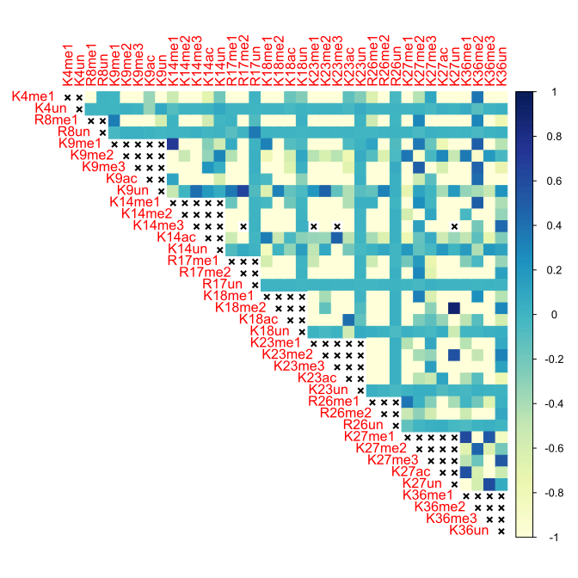

# Figure S31

Liver, 10 months, Histone H3.3

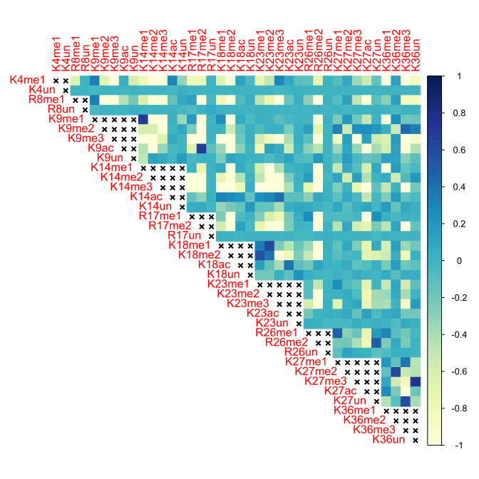

# Figure S32

Liver, 18 months, Histone H3.2

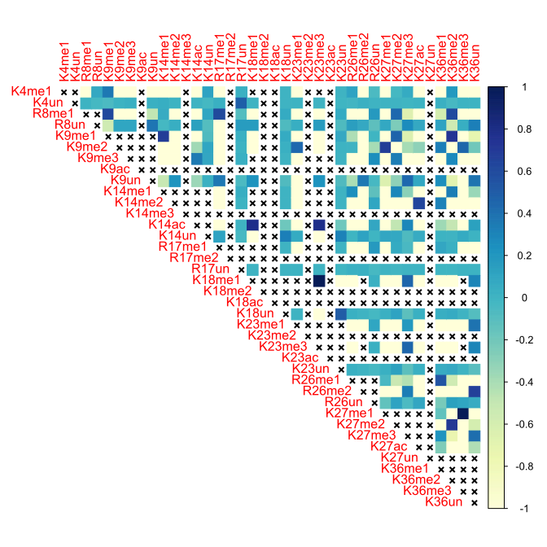

# Figure S33

Liver, 18 months, Histone H3.3

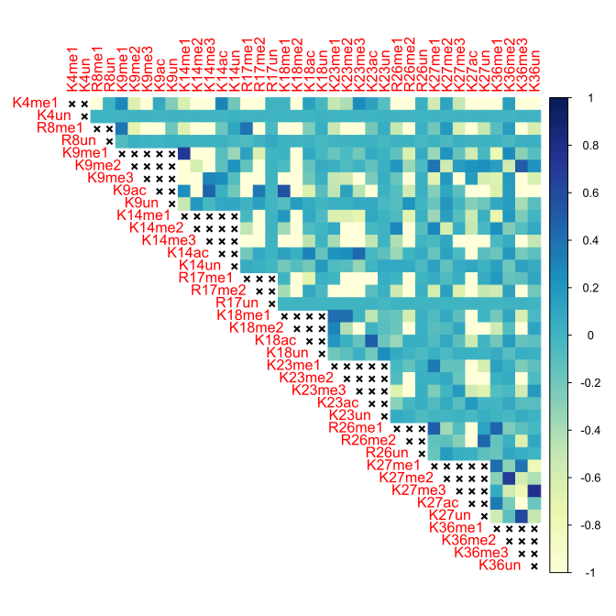

# Figure S34

Liver, 24 months, Histone H3.2

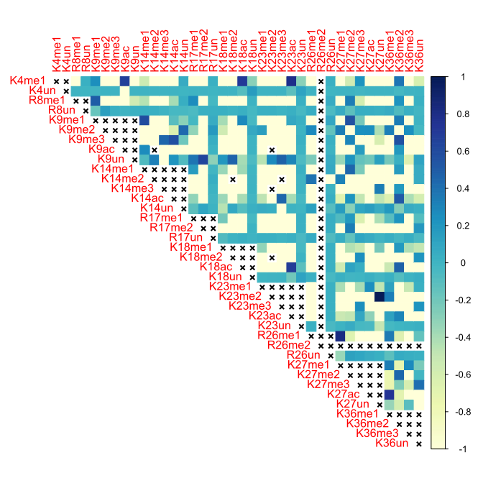

# Figure S35

Liver, 24 months, Histone H3.3

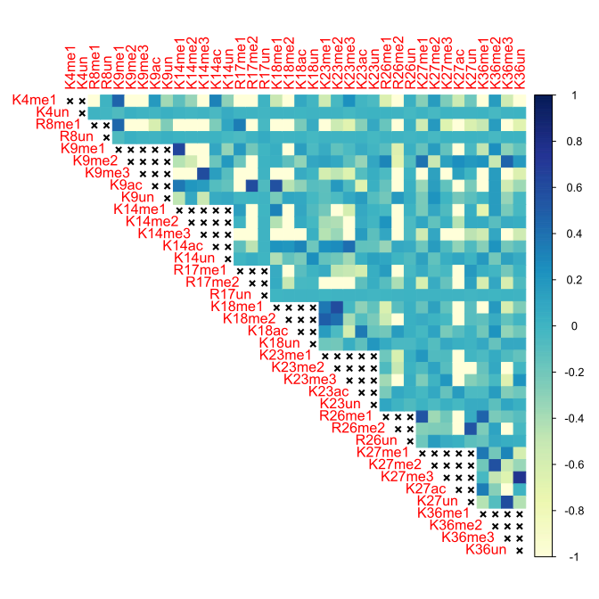

# Figure S36

Liver, 3 months, Histone H3.2

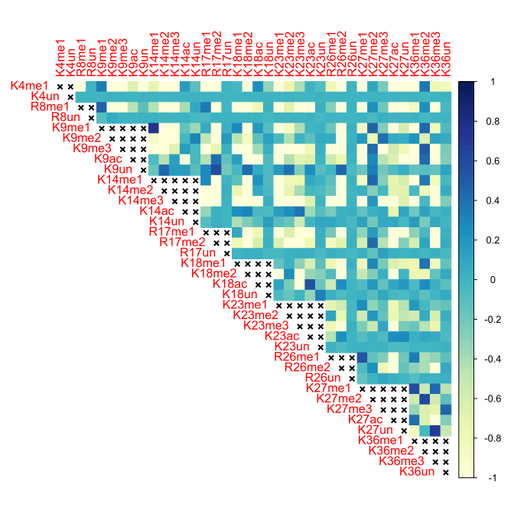

# Figure S37

Liver, 3 months, Histone H3.3

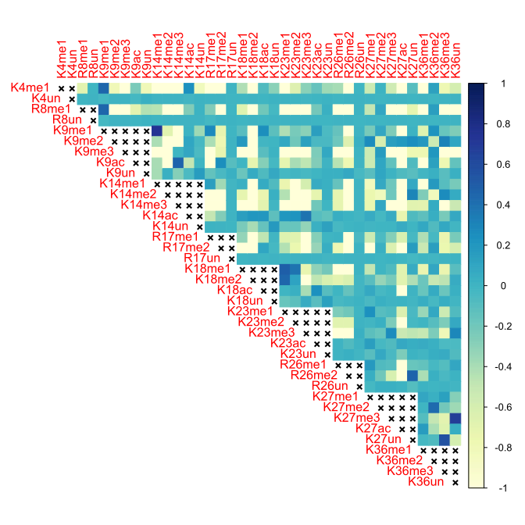

# Figure S38

Liver, 5 months, Histone H3.2

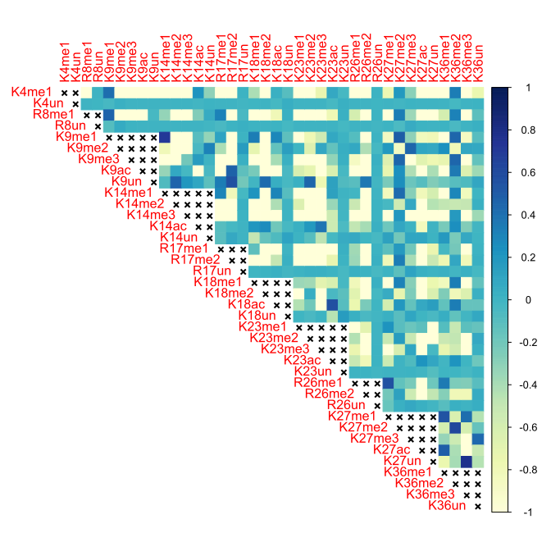

# Figure S39

Liver, 5 months, Histone H3.3

